**Shopper’s-hunt**

Devi Pranathi Vinturi

Department of Information Science

University of North Texas

INFO 5707: Data Modeling for Information Professionals

Jiankun Liu

April 26, 2023

**Objective:**

An objective for an e-commerce website could be to provide a convenient and user-friendly platform for customers to purchase products and services online. The website should aim to:

1. Increase sales and revenue by expanding the business to a wider audience.
2. Improve customer satisfaction by providing a seamless and secure shopping experience.
3. Build brand awareness and loyalty through effective marketing strategies.
4. Collect and analyze data to make informed business decisions.
5. Offer personalized recommendations and promotions based on customer behaviour.
6. Provide efficient and reliable customer support to enhance the overall experience.

**Scope:**

The scope of an e-commerce website could also include:

1. Integration with payment gateways and shipping carriers for seamless transactions and delivery.
2. Secure login and registration functionality to protect customer data and prevent fraud.
3. Advanced search capabilities and filtering options to improve product discovery.
4. Inventory management features to track stock levels and prevent overselling.
5. Analytics tools to monitor website traffic, sales performance, and customer behaviour.
6. Mobile-responsive design to provide a seamless experience across devices.

**User Requirements:**

1. Users should be able to browse products by category, brand, or search keywords.
2. Users should be able to view detailed information about each product, including images, descriptions, and customer reviews.
3. Users should be able to add products to a shopping cart and view the cart contents.
4. Users should be able to check out and make payments securely.
5. Users should be able to create and manage their accounts, including updating personal information, viewing order history, and tracking shipments.
6. Users should be able to easily contact customer support for assistance with orders, product inquiries, or technical issues.
7. Users should be able to leave feedback and ratings on products and the overall shopping experience.

**Business Rules:**

1. Products must have a unique SKU (stock-keeping unit) to help with inventory management.
2. Prices must be consistent across all channels (i.e., website, mobile app, physical store).
3. Shipping rates and delivery times must be clearly communicated to customers.
4. Payment processing must comply with PCI (Payment Card Industry) security standards.
5. Customer data must be protected in accordance with privacy laws and regulations.
6. All product descriptions, images, and pricing must be accurate and up-to-date to avoid misleading customers.
7. The website should comply with all relevant laws and regulations related to e-commerce, such as consumer protection, privacy, and data security.

8 entities that could be used to model an e-commerce website:

1. Customer - This entity would include information such as name, email, shipping address, billing address, and payment method. It could also include additional fields for tracking customer behavior and preferences.
2. Product - This entity would include information such as product name, description, price, SKU, and inventory levels. It could also include fields for product categories, brands, and reviews.
3. Order - This entity would include information such as order number, order date, customer ID, and payment information. It could also include fields for order status, shipping information, and discounts.
4. Cart - This entity would include information such as customer ID, product ID, quantity, and price. It would be used to track the items currently in a customer's shopping cart.
5. Category - This entity would include information such as category name, description, and parent category (if applicable). It would be used to organize products and facilitate browsing.
6. Brand - This entity would include information such as brand name, description, and logo. It would be used to identify and promote products from specific brands.
7. Review - This entity would include information such as product ID, customer ID, rating, and review text. It would be used to collect and display customer feedback on products.
8. Order_details: This entity represents a specific instance of a product being ordered as part of an order. It includes information about the quantity and price of the product in that order. The "order_id" and "product_id" foreign keys allow the order detail to be linked to the specific order and product it corresponds to.
9. Admin - This entity would include information such as username, password, and permissions. It would be used to control access to the website's backend and manage product, order, and customer data.

**Shopper’s-hunt E-R Diagram**

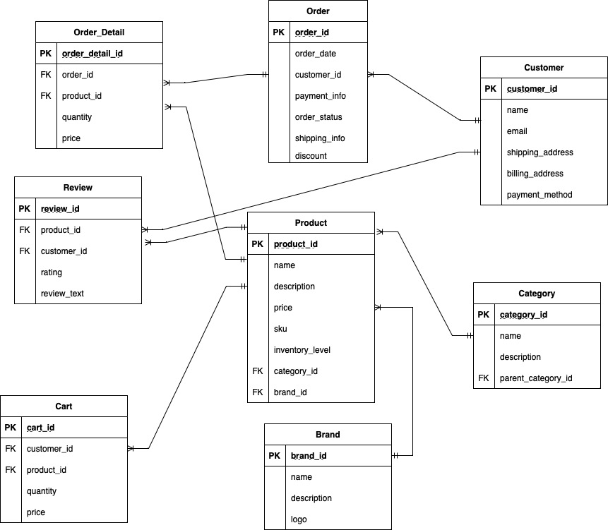

**DATA DICTIONARY**

